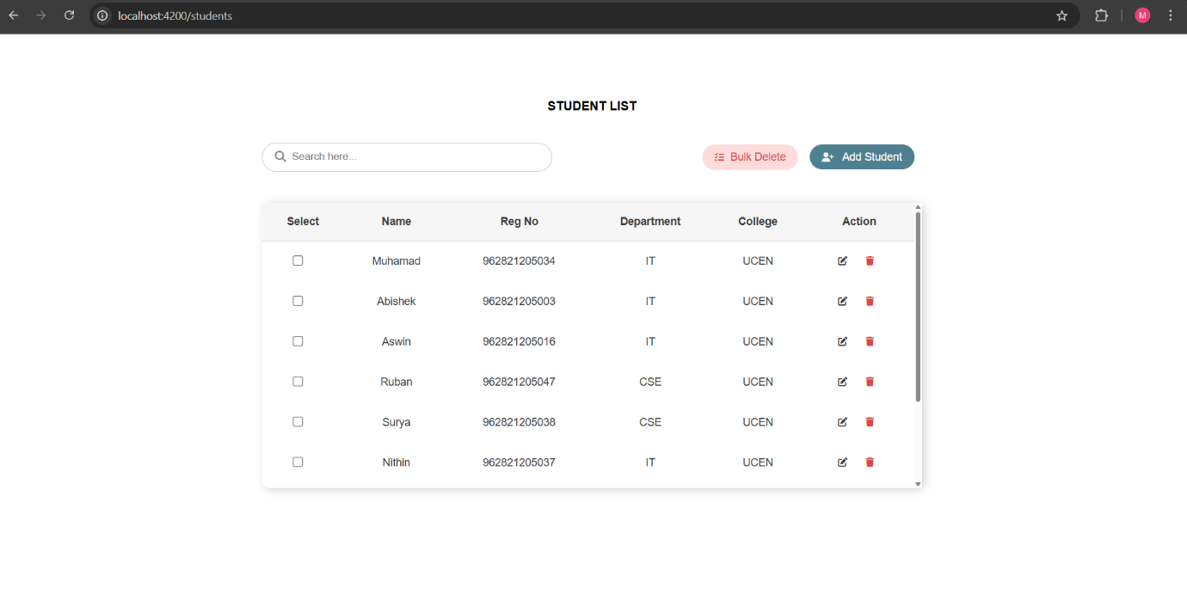**OUTPUT:**

**List Route**( localhost:4200/students ) **:**

**Add Route**( localhost:4200/students/add ) **:**

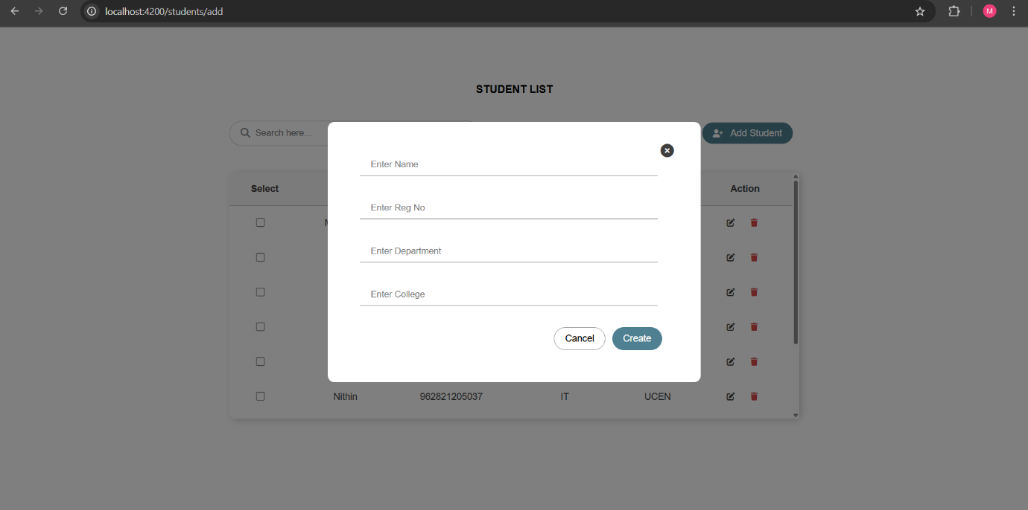

**Edit Route**( localhost:4200/students/edit/962821205034 ) **:**

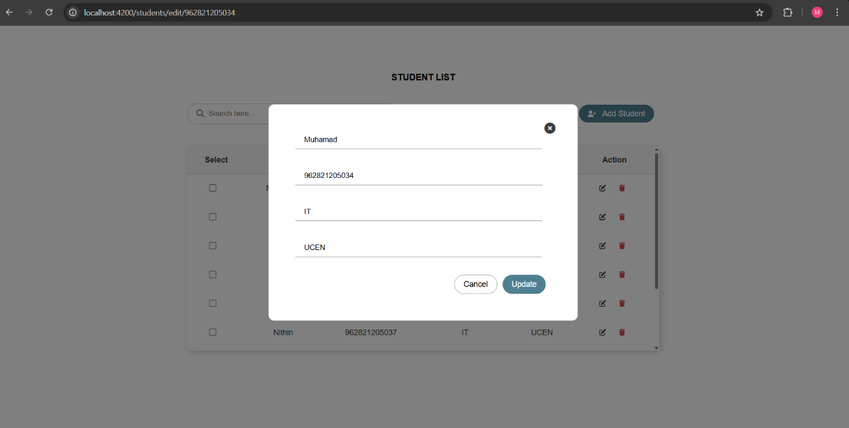

**index.html**

<!DOCTYPE html>

<html>

  <head>

    <meta charset="utf-8">

    <title>EmberListView</title>

    <meta name="description" content="">

    <meta name="viewport" content="width=device-width, initial-scale=1">

    {{content-for "head"}}

    <link integrity="" rel="stylesheet" href="{{rootURL}}assets/vendor.css">

    <link integrity="" rel="stylesheet" href="{{rootURL}}assets/ember-list-view.css">

    <link rel="stylesheet" href="https://cdnjs.cloudflare.com/ajax/libs/font-awesome/6.7.2/css/all.min.css" integrity="sha512-Evv84Mr4kqVGRNSgIGL/F/aIDqQb7xQ2vcrdIwxfjThSH8CSR7PBEakCr51Ck+w+/U6swU2Im1vVX0SVk9ABhg==" crossorigin="anonymous" referrerpolicy="no-referrer" />

    {{content-for "head-footer"}}

  </head>

  <body>

    {{content-for "body"}}

    <script src="{{rootURL}}assets/vendor.js"></script>

    <script src="{{rootURL}}assets/ember-list-view.js"></script>

    {{content-for "body-footer"}}

  </body>

</html>

**templates/application.hbs**

{{outlet}}

**templates/students.hbs**

<div class="container">

    <h4>STUDENT LIST</h4>

    <div class="searchDlt">

        <div class="search-cont">

            <i class="fa-solid fa-magnifying-glass"></i>

            <input type="text" id="search" placeholder="Search here..." {{on "keyup" this.searchTable}}>

        </div>

        <div>

            <button {{on "click" this.bulkDelete}} class="btn-cd dlt"><i class="fa-solid fa-list-check"></i>Bulk Delete</button>

            <LinkTo @route="students.add" class="btn-cd">

                <i class="fa-solid fa-user-plus"></i> Add Student

            </LinkTo>

        </div>

    </div>

    <StudentList @students={{this.students.students}} @deleteRow={{this.deleteRow}} @editRow={{this.editRow}} />

</div>

{{#if this.isFormVisible}}

<StudentForm @editStudent={{this.editStudent}} @students={{this.students.students}} @saveStudent={{this.saveStudent}}

    @updateStudents={{this.updateStudents}} @closeForm={{this.closeForm}} />

{{/if}}

{{outlet}}

**templates/students/add.hbs**

<div id="overlay"></div>

<StudentForm @addRow={{this.addRow}} @closeForm={{this.closeForm}}/>

**templates/students/edit.hbs**

<div id="overlay"></div>

<StudentForm

  @editStudent={{this.model}}

  @students={{this.students.students}}

  @saveStudent={{this.saveStudent}}

  @updateStudents={{this.updateStudents}}

  @closeForm={{this.closeForm}}

/>

**services/students.js**

import Service from '@ember/service';

import { tracked } from '@glimmer/tracking';

export default class StudentsService extends Service {

    @tracked students = [

            { name: "Muhamad", reg: 962821205034, dept: "IT", clg: "UCEN" },

            { name: "Abishek", reg: 962821205003, dept: "IT", clg: "UCEN" },

            { name: "Aswin", reg: 962821205016, dept: "IT", clg: "UCEN" },

            { name: "Ruban", reg: 962821205047, dept: "CSE", clg: "UCEN" },

            { name: "Surya", reg: 962821205038, dept: "CSE", clg: "UCEN" },

            { name: "Nithin", reg: 962821205037, dept: "IT", clg: "UCEN" },

            { name: "Jees", reg: 962821205050, dept: "IT", clg: "UCEN" },

            { name: "Nithish", reg: 962821205040, dept: "IT", clg: "UCEN" },

            { name: "Jones", reg: 962821205008, dept: "IT", clg: "UCEN" },

        ];;

    addStudent(student) {

        this.students = [...this.students, student];

    }

}

**routes/students.js**

import Route from '@ember/routing/route';

export default class StudentsRoute extends Route {}

**routes/students/add.js**

import Route from '@ember/routing/route';

import { inject as service } from '@ember/service';

export default class StudentsAddRoute extends Route {

    @service students;

    model() {

        return { students:this.students.students, newStudent: { name: '', reg: '', dept: '', clg: '' } };

    }

}

**routes/students/edit.js**

import Route from '@ember/routing/route';

import { inject as service } from '@ember/service';

export default class StudentsEditRoute extends Route {

    @service students;

    model(params) {

        return this.students.students.find(student => student.reg == Number(params.reg));

    }

}

**controllers/students.js**

import Controller from '@ember/controller';

import { action } from '@ember/object';

import { tracked } from '@glimmer/tracking';

import { inject as service } from '@ember/service';

export default class StudentsController extends Controller {

    @service router;

    @service students;

    @tracked isFormVisible = false;

    @tracked editStudent = null;

    @action bulkDelete() {

        let checkboxes = document.querySelectorAll("#table input[type='checkbox']:checked");

        if (!checkboxes.length) {

            alert("Select one or more rows to bulk delete");

            return;

        }

        checkboxes.forEach(checkbox => {

            let row = checkbox.parentElement.parentElement;

            this.deleteRow(row.cells[2].textContent);

            row.remove();

        });

    }

    @action searchTable(event) {

        let input = event.target.value.toLowerCase();

        let rows = document.querySelectorAll("#table tr");

        rows.forEach((row, index) => {

            if (index === 0) return;

            row.style.display = row.innerText.toLowerCase().includes(input) ? "" : "none";

        });

    }

    @action deleteRow(reg) {

        this.students.students = this.students.students.filter(student => student.reg !== reg);

    }

    @action editRow(reg) {

        this.editStudent = this.students.students.find(student => student.reg === reg);

        this.router.transitionTo('students.edit', reg);

    }

}

**controllers/students/add.js**

import Controller from '@ember/controller';

import { inject as service } from '@ember/service';

import { action } from '@ember/object';

export default class StudentsAddController extends Controller {

    @service router;

    @service students;

    @action addRow(student) {

        this.students.addStudent(student);

        console.log("Updated Students List:", this.students.students);

        this.router.transitionTo('students');

    }

    @action closeForm() {

        this.router.transitionTo('students');

    }

}

**controllers/students/edit.js**

import Controller from '@ember/controller';

import { inject as service } from '@ember/service';

import { action } from '@ember/object';

export default class StudentsEditController extends Controller {

    @service router;

    @service students;

    @action updateStudents(updatedStudents) {

        this.students.students = updatedStudents;

        this.router.transitionTo('students');

    }

    @action closeForm() {

        this.router.transitionTo('students');

    }

}

**components/student-form.hbs**

<div id="formCont">

    <span id="close-btn" {{on "click" @closeForm}}>

        <i class="fa-solid fa-circle-xmark"></i>

    </span>

    <input type="text" value={{this.name}} {{on "input" this.updateName}} placeholder="Enter Name">

    <input type="text" value={{this.reg}} {{on "input" this.updateReg}} placeholder="Enter Reg No">

    <input type="text" value={{this.dept}} {{on "input" this.updateDept}} placeholder="Enter Department">

    <input type="text" value={{this.clg}} {{on "input" this.updateClg}} placeholder="Enter College">

    <div class="decision">

        <button class="btn-cd cancel" type="button" {{on "click" @closeForm}}>Cancel</button>

        <button class="btn-cd" type="button" {{on "click" this.saveStudent}}>{{if this.isEditing "Update" "Create"}}</button>

    </div>

</div>

**components/student-list.hbs**

<div class="table-container">

    <table id="table">

        <tr>

            <th>Select</th>

            <th>Name</th>

            <th>Reg No</th>

            <th>Department</th>

            <th>College</th>

            <th>Action</th>

        </tr>

        {{#each @students as |student|}}

        <tr>

            <td><input type="checkbox"></td>

            <td>{{student.name}}</td>

            <td>{{student.reg}}</td>

            <td>{{student.dept}}</td>

            <td>{{student.clg}}</td>

            <td><button class="btn btn-edit" type="button" {{on "click" (fn @editRow student.reg)}}><i class="fa-solid fa-pen-to-square"></i></button>

            <button class="btn btn-dlt" type="button" {{on "click" (fn @deleteRow student.reg)}}><i class="fa-solid fa-trash"></i></button></td>

        </tr>

        {{/each}}

    </table>

</div>

**components/student-form.js**

import Component from '@glimmer/component';

import { action } from '@ember/object';

import { tracked } from '@glimmer/tracking';

export default class StudentFormComponent extends Component {

    @tracked name = this.args.editStudent?.name || '';

    @tracked reg = this.args.editStudent?.reg || '';

    @tracked dept = this.args.editStudent?.dept || '';

    @tracked clg = this.args.editStudent?.clg || '';

    @tracked isEditing = !!this.args.editStudent;

    @action updateName(event) {

        this.name = event.target.value;

    }

    @action updateReg(event) {

        this.reg = event.target.value;

    }

    @action updateDept(event) {

        this.dept = event.target.value;

    }

    @action updateClg(event) {

        this.clg = event.target.value;

    }

    @action saveStudent() {

        if(!this.name || !this.reg || !this.dept || !this.clg) {

            alert("Fill all the details");

            return;

        }

        if (this.isEditing) {

            let updatedStudents = this.args.students.map(student =>

                student.reg === this.reg

                    ? { ...student, name: this.name, dept: this.dept, clg: this.clg }

                    : student

            );

            this.args.updateStudents(updatedStudents);

        } else {

            this.args.addRow({

                name: this.name,

                reg: this.reg,

                dept: this.dept,

                clg: this.clg

            });

        }

        this.args.closeForm();

    }

}

**styles/app.css**

/* Ember supports plain CSS out of the box. More info: https://cli.emberjs.com/release/advanced-use/stylesheets/ */

body {

    display: flex;

    justify-content: center;

    align-items: center;

    height: 90vh;

    font-family: Arial, Helvetica, sans-serif;

}

#overlay {

    position: fixed;

    top: 0;

    left: 0;

    height: 100%;

    width: 100%;

    background: rgb(0 0 0 / 50%);

    z-index: 1000;

}

.container {

    display: flex;

    align-items: center;

    flex-direction: column;

    padding: 2rem;

    background-color: #fff;

    border-radius: 10px;

    width: 70%;

    height: 75vh;

    position: relative;

}

#formCont,table {

    margin: 2rem;

}

#formCont {

    display: flex;

    flex-direction: column;

    gap: 2rem;

    position: absolute;

    background-color: white;

    padding: 3rem;

    border-radius: 10px;

    width: 30%;

    z-index: 1001;

}

.decision {

    display: flex;

    justify-content: flex-end;

}

#close-btn {

    cursor: pointer;

    position: absolute;

    top: 2rem;

    right: 2rem;

    color: #3e3e3e;

    font-size: 20px;

}

input {

    margin-right: 1rem;

    padding: 0.5rem 1rem;

    border: none;

    border-bottom: 1px solid #868686;

    background-color: #fff;

    outline: none;

}

input[type="text"]:focus {

    border: none;

    border-bottom: 1px solid #868686;

}

input[type="checkbox"] {

    cursor: pointer;

}

.table-container {

    height: auto;

    overflow-y: scroll;

    scrollbar-width: thin;

    box-shadow: 3px 2px 10px #d3d3d3;

    margin: 1.5rem;

    width: 80%;

    border-radius: 10px;

}

table {

    background-color: #fff;

    border-radius: 10px;

    border-collapse: collapse;

    color: #3e3e3e;

    margin: 0;

    width: 100%;

}

td,th {

    padding: 1rem;

    font-size: 14px;

    text-align: center;

}

th {

    position: sticky;

    top: 0;

    border-bottom: 1px solid #ccc;

    background-color: #f6f6f6;

}

.btn-cd {

    padding: 0.5rem 1rem;

    border-radius: 20px;

    border: none;

    background-color: #4f8091;

    color: white;

    cursor: pointer;

    font-size: 14px;

    margin-right: 10px;

    text-decoration: none;

}

.btn-cd i {

    font-size: 12px;

}

i {

    margin-right: 0.5rem;

}

.dlt {

    background-color: #ffdcdc;

    color: #d84949;

}

.cancel {

    background-color: white;

    color: black;

    border: 1px solid #9f9f9f;

}

.btn {

    background: transparent;

    border: none;

    cursor: pointer;

}

.btn-dlt {

    color: #d84949;

}

.btn-edit {

    color: #3e3e3e;

}

button i {

    font-size: 12px;

}

.searchDlt {

    width: 80%;

    display: flex;

    justify-content: space-between;

    align-items: center;

    margin: 1rem;

    gap: 1rem;

}

#search {

    padding: 10px 0;

    border: none;

    width: 100%;

}

.search-cont {

    display: flex;

    align-items: center;

    border: 1px solid #ccc;

    width: 40%;

    color: #878787;

    padding: 0 1rem;

    border-radius: 20px;

}

.search-cont i {

    font-size: 14px;

}

**package.json**



